CONGREGATIONAL*SEDER*

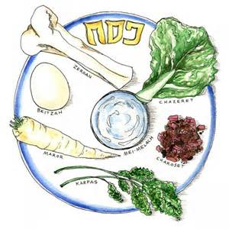

JOIN YOUR SHAAREY ZEDEK FAMILY FOR THE

FIRST NIGHT OF PASSOVER

**Wednesday, April 8 at 6:00 p.m.** for a light dinner filled with wonderful music, new and old friends alike, and our special *Haggadah*.

***MENU***: *Matzah* Ball Soup; Traditional *Seder* Plate items including *Charoset*, Chopped Liver, Gefilte Fish; Fresh Green Salad; Fruit; and Wonderful Desserts

**Volunteers are needed to help prepare, serve, and/or clean up. If you can help, please contact Roslyn Covey at roslyncovey@att.net or 230-6065**

**Please make your reservations by April 1 * Limited to 100 reservations - No walk-ins, please.**

**$17 per adult, $8 per child 6-12, children under 5 FREE**

(Complimentary tickets are available for our members only – Contact Rabbi Bigman)

**Mail check, payable to “Shaarey Zedek Sisterhood,” to**

Congregation Shaarey Zedek, 1924 Coolidge Road, East Lansing, MI 48823

Questions? Call Roslyn Covey or for complimentary tickets call Rabbi Bigman at 351-3570 x2

*SEDER* RESERVATION FORM

Name______________________________________________________

No. of Adults $17 x_____________ = $_________________

No. of Children 6-12 years old $8 x______________ =$_________________

No. under 5 years _____________ no charge

TOTAL Enclosed $___________________________